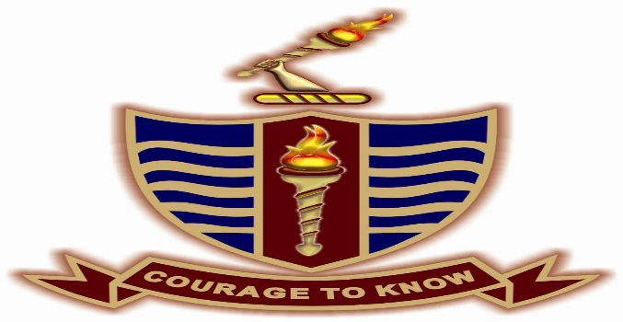

|  |  |
| --- | --- |
| **Instructor:** | Mr. Ali Raza |
| **Course:** | Software Engineering |
| **Date of Submission:** | 3rdOctober,2024 |

**PROJECT’S TITLE:**

BANK MANAGEMENT SYSTEM

**PROJECT’S MEMBER:**

* **IQRA KHALIQUE (0062-BSCS-22)**
* **ZARAFSHAN ARJUMAND (0070-BSCS-22)**
* **AYESHA YOUSAF (0024-BSCS-22)**

**PROJECT’S PROPOSAL:**